

**Reminder 365  
User Requirement Specifications (URS)**

|  |  |
| --- | --- |
| Version | 0.4 |
| Date | 17-Nov-2017 |



Document Control:

Revision History

|  |  |  |  |  |
| --- | --- | --- | --- | --- |
| **Version** | **Date** | **Author** | **Reviewer** | **Summary of Changes** |
| 0.1 | 01 Nov 2017 | Abhishek Saini | Aliabbas Khambata |  |
| 0.2 | 13 Nov 2017 | Abhishek Saini | Aliabbas Khambata |  |
| 0.3 | 16 Nov 2017 | Jiang Wensi |  |  |
| 0.4 | 17 Nov 2017 | Abhishek Saini | Aliabbas Khambata | Changes incorporated as suggested by PSA |

PSA Members

|  |  |  |  |  |  |
| --- | --- | --- | --- | --- | --- |
| **Name** | **Designation** | **Contact** | **Date** | **Approval Method** | **Approval Reference** |
| Sean Seah | Deputy Manager |  |  |  |  |
| Jiang Wensi | System Analyst |  |  |  |  |
|  |  |  |  |  |  |

Saksoft Members

|  |  |  |  |  |  |
| --- | --- | --- | --- | --- | --- |
| **Name** | **Designation** | **Contact** | **Date** | **Approval Method** | **Approval Reference** |
| Aliabbas Khambata | Project Manager |  |  |  |  |
| Aditya Nalla | Delivery Manager |  |  |  |  |
| Abhishek Saini | Business Analyst |  |  |  |  |
|  |  |  |  |  |  |

Distribution List

|  |  |  |
| --- | --- | --- |
| **Name** | **Contact Details** | **Purpose** |
|  |  |  |

**Table of Contents**

1 Purpose 5

2 Problem / Purpose Statement 6

3 Scope 7

4 Benefits 8

5 Glossary 9

6 Business Process 10

6.1 Current Business Process 10

6.2 New Business Process 10

7 Functional Requirements 11

7.1 Authentication and Authorization Module 11

7.1.1 Login and Logout 11

7.1.2 Manage User 11

7.1.3 Manage User Group and Role 14

7.1.4 Manage My User Group 17

7.2 Contract Reminder Module 19

7.2.1 Contract Creation 20

7.2.2 Update Contracts 21

7.2.3 Delete Contracts 22

7.2.4 Renewing Contracts 22

7.2.5 Maker-checker workflow 23

7.2.6 Reminder Calendar 25

7.2.7 Contract Reminder Summaries 25

7.2.8 Search Contracts 25

7.2.9 Sort Contacts 25

7.2.10 Download Contracts 25

7.2.11 Reminder Workflow 26

7.2.12 Email for Expiring Contracts 27

7.2.13 Transaction Logs 27

8 Performance 28

9 Interface Requirements 29

10 Operational Requirements 30

10.1 Logging requirement (application logs) 30

11 Security/Control Requirements 31

12 Documentation Requirements 32

13 User Training Requirements 33

14 Output Requirements 34

15 Paging Requirements 35

16 User acceptance criteria 36

# Purpose

This document records the requirements, both functional and non-functional, of the systems to be developed. It serves as a contract between the customer/user and the developers. It is also an essential input to activities in analysis, design and test.

# Problem / Purpose Statement

Currently the expiry dates for equipment in store and crafts, Staff’s certificates such as work permit, safety certificates and contracts are tracked manually in spread sheet. This is not productive and sometimes they might not be renewed in time. This lapse might result in failure to service jobs and hence, there is a requirement for web application to make the tracking automatic.

# Scope

The following features will be in the scope of this project:

* Login and Logout
* Manage User Group and Role
* Manage User within User Group
* Contracts Reminder Module
* Equipment Reminder Module
* Staff Reminder Module
* Notifications
* Dashboard
* Administrative Module

# Benefits

The following will be the benefits of having this system

* Higher Efficiency and Consistency in Planning & Operation
* Higher Productivity by Automating Work Processes where possible

# Glossary

|  |  |
| --- | --- |
| **Abbreviation/  Terminology** | **Definition** |
| PSA | PSA Marine (Pte) Ltd |
| DR | Disaster Recovery |
| B9 | Brani Base |
| WCB | West Coast Base |
| User | PSA Internal Staff |
| Crew | Staff working in Tug/Launch/Waterboat |
| R365 | Reminder 365 Web App |

# Business Process

## Current Business Process

## New Business Process

# Functional Requirements

## Authentication and Authorization Module

This section will describe the list of features required by the user to access R365 and for administrative users to manage the groups, roles and users for contract, staff and equipment module.

### Login and Logout

This feature shall allow R365 users to login and logout from the system based on the validity of his window active directory or LDAP account.

User can access R365 via R365 Login Page. User needs to enter Login ID and password to login R365. User’s login ID and password shall be encrypted when authenticating against PSA Window Active Directory or LDAP. Upon successful login, the authorized modules (Contract, Staff and equipment) shall be made available to the user. Module shall comply with PSA’s Password Policy and PSA’s User Account and Access Management Policy. There will be a “FORGET PASSWORD?” link in R365 login page. Popup message “Please contact Helpdesk @ 62795459 or email helpdesk_psa@globalpsa.com for help.” will be shown if user clicks “FORGET PASSWORD?”

The Systems shall log out a user if there is no activity for a period that is to be defined by the System Administrator. Provide option for system administrator to define the session length to keep the user logged in for a period of time. Upon session expiration, system logoff and/or whenever user click on the browser “back” button, they shall be re-directed to the login page for authentication

Every transactional action shall be logged in the application log and database.

### Manage User

This feature shall allow Overall User Administrator to manage (create, update, delete, view, search, filter, sort) users in R365.

Whenever user details are submitted for creation / update / deletion, R365 shall prompt up a confirmation dialogue asking user to confirm his action.

Whenever a user is created / updated / deleted successfully or unsuccessfully, R365 shall display a confirmation message saying that this user is created / update / deleted successfully or unsuccessfully. User ID shall be included in the confirmation message whenever possible.

#### Create User

This feature will allow Overall User Administrator to create users in R365. Following details will be entered in create user page:

|  |  |
| --- | --- |
| **Fields** | **Remarks** |
| User ID* | Text |
| User Name* | Text, retrieve from Windows AD and editable. |
| Email* | Valid Email ID, retrieve from Windows AD and editable. |
| Phone Number | +65-XXXX-XXXX, retrieve from Windows AD and editable. |
| Overall User Admin | Yes / No (default), checkbox.  If “Overall User Admin” is selected, this user will be able to manage users in R365. |
| Overall Group Admin | Yes / No (default), checkbox.  If “Overall Group Admin” is selected, this user will be able to manage groups in R365. |
| Remarks | Text |

Access rights of Overall User Administrator and Overall Group Administrator will be configurable in database

|  |  |  |  |  |  |  |  |  |
| --- | --- | --- | --- | --- | --- | --- | --- | --- |
| Role / Access | View User | Create User | Update User | Delete User | View Group | Create Group | Update Group | Delete Group |
| Overall Group Administrator | X | X | X | X |  |  |  |  |
| Overall User Administrator |  |  |  |  | X | X | X | X |

#### Update User

This feature will allow Overall User Administrator to update user details in R365. Following details will be displayed or editable in update user details page:

|  |  |  |
| --- | --- | --- |
| **Fields** | **Editable** | **Remarks** |
| User ID* | Y | Text |
| User Name* | Y | Text, retrieve from Windows AD and editable. |
| Email* | Y | Valid Email ID, retrieve from Windows AD and editable. |
| Phone Number | Y | +65-XXXX-XXXX, retrieve from Windows AD and editable. |
| Overall User Admin | Y | Yes / No, checkbox. |
| Overall Group Admin | Y | Yes / No, checkbox. |
| Remarks | Y | Text |
| Created By | N | Text |
| Created Date | N | DD/MM/YYYY HH:MM:SS |
| Last Modified | N | Text |
| Last Modified Date | N | DD/MM/YYYY HH:MM:SS |

#### Delete User

This feature will allow Overall User Administrator to delete user from R365. When a user is deleted, it will be logically deleted from database. However, user is not allowed to be deleted if he is the only group administrator of a user group.

#### View User Details

This feature will allow Overall User Administrator to view user details in R365. Following fields will be shown in user details page:

|  |  |
| --- | --- |
| **Fields** | **Remarks** |
| User ID | Text |
| User Name | Text |
| Email | Text |
| Phone Number | Text |
| Overall User Admin | Yes / No |
| Overall Group Admin | Yes / No |
| Remarks | Text |
| Created By | Text |
| Created Date | DD/MM/YYYY HH:MM:SS |
| Last Modified | Text |
| Last Modified Date | DD/MM/YYYY HH:MM:SS |

#### View My User Details

This feature will allow user to view his or her user details in user profile page. Following fields will be shown:

|  |  |
| --- | --- |
| **Fields** | **Remarks** |
| User ID | Text |
| User Name | Text |
| Email | Text |
| Phone Number | Text |
| Group & Role | Display User Group & Role information if any |
| Overall User Admin | If is “Overall User Admin”, display “Yes”. Else, hide this field. |
| Overall Group Admin | If is “Overall Group Admin”, display “Yes”. Else, hide this field. |
| Remarks | Text |
| Created By | Text |
| Created Date | DD/MM/YYYY HH:MM:SS |
| Last Modified | Text |
| Last Modified Date | DD/MM/YYYY HH:MM:SS |

#### Search User

This feature will allow Overall User Administrator to search users via any keywords in user details. Search via keyword function shall be enhanced by “Search as you type” feature.

#### Sort User

This feature will allow Overall User Administrator to sort user search result by any column in the result list.

### Manage User Group and Role

This feature shall allow Overall Group Administrator to manage (create, search via keywords, filter, sort, view, modify and delete) user groups and corresponding user roles such as “Group Administrator”, “Officer-in-Charge”, “Read-only User”, “User” and etc. for that particular group. The search via keyword function shall be enhanced by “search as you type” feature.

Whenever User Group details are submitted for creation / update / deletion, R365 shall prompt up a confirmation dialogue asking user to confirm his action.

Whenever a group is created / updated / deleted successfully or unsuccessfully, R365 shall display a confirmation message saying that this group is created / update / deleted successfully or unsuccessfully. Group Name shall be included in the confirmation message whenever possible.

User Group and role will follow the following hierarchy:-

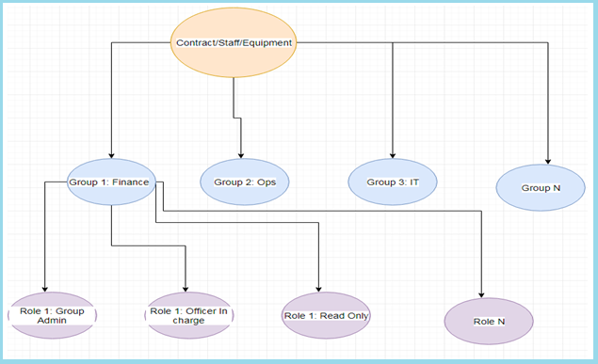

|  |  |  |  |  |  |  |  |
| --- | --- | --- | --- | --- | --- | --- | --- |
| Role / Access | Add Reminder | View Reminder | Update Reminder | Delete Reminder | Approve Reminder | Notification TO | Notification CC |
| Group Administrator | X | X | X | X | X | X |  |
| Officer in Charge | X | X | X | X | X | X |  |
| Read-only User |  | X |  |  |  |  | X |
| User | X | X | X | X | X |  | X |

Points to remember:

* One group may have more than one role. However, a user can have only one role in a same user group. E.g.
  + User D can be either “Administrator” or “Officer-In-Charge” in FMD-OPS-STAFF group.
  + User E can be “Officer-In-Charge” in FMD-OPS-STAFF, and “Viewer” in FMD-OPS-EQUIP group.
  + One reminder module may have multiple groups. However, one group can have only one reminder module.

#### Creation of User groups and roles

This feature will allow the Overall Group Administrator to create user groups in R365 for users to access reminders in their groups. When Overall Group Administrator creates a user group, he will create roles, and assign user(s) as Group Administrator in the group.

Following details will be entered to create a User Group:

|  |  |
| --- | --- |
| **Fields to be entered** | **Remarks** |
| Reminder Module* | Dropdown (Contract, Equipment and Staff) |
| Group Name* | Text |
| Group Description | Text Area |
| Role(s)* | Grid   |  |  | | --- | --- | | Role* | Text | | Add Reminder | Checkbox | | View Reminder | Checkbox | | Update Reminder | Checkbox | | Delete Reminder | Checkbox | | Approve Reminder | Checkbox  Verify checkbox is enabled only when contract reminder module is selected. | | Notification TO | Checkbox | | Notification CC | Checkbox | | Action | Add button, Delete button |   Add/View/Update/Delete: Any one value should be selected mandatory |
| Group Administrator | Assign one or two users as Group Administrator |
| Active* | Dropdown (Yes/No) |

Group administrator will be a default role for any group with all the permissions of Add, View, Update, Delete and Verify enabled. To assign a user as Group Administrator, Overall Group Admin will firstly search the user, and then assign him / her as Group Administrator. Search as you type feature is required for searching user.

#### View User Groups

This feature will allow Overall Group Administrator to view user groups in R365. Following details will be displayed in Group Details:

|  |  |
| --- | --- |
| **Fields** | **Remarks** |
| Reminder Module | Text |
| Group Name | Text |
| Group Description | Text |
| Role(s) | Grid   |  |  | | --- | --- | | Role | Text | | Add Reminder | Checkbox | | View Reminder | Checkbox | | Update Reminder | Checkbox | | Delete Reminder | Checkbox | | Approve Reminder | Checkbox | | Notification TO | Checkbox | | Notification CC | Checkbox | |
| Group Administrator | Text |
| Active | Yes / No |
| Created By | Text |
| Created Date | DD/MM/YYYY HH:MM:SS |
| Last Modified | Text |
| Last Modified Date | DD/MM/YYYY HH:MM:SS |

#### Update User Group

This feature will allow Overall Group Administrator to update User Group Details. Following details will be shown or editable in update user group page:

|  |  |  |
| --- | --- | --- |
| **Fields** | **Editable** | **Remarks** |
| Reminder Module | N | Text |
| Group Name* | Y | Text |
| Group Description | Y | Text |
| Role(s) | Y | Grid   |  |  | | --- | --- | | Role | Text | | Add Reminder | Checkbox | | View Reminder | Checkbox | | Update Reminder | Checkbox | | Delete Reminder | Checkbox | | Approve Reminder | Checkbox | | Notification TO | Checkbox | | Notification CC | Checkbox | |
| Group Administrator* | Y | Assign one or two users as Group Administrator |
| Active | Y | Yes / No |
| Created By | N | Text |
| Created Date | N | DD/MM/YYYY HH:MM:SS |
| Last Modified | N | Text |
| Last Modified Date | N | DD/MM/YYYY HH:MM:SS |

#### Delete User Group

This feature will allow Overall Group Administrator to delete a User Group from R365. When a user group is deleted, it will be deleted from R365, and all reminders in this group will be deleted as well.

#### Search User Group

This feature will allow Overall Group Administrator to search user groups via any keywords in User Group details. Search via keywords function will be enhanced by “Search as you type” feature.

#### Sort User Group

This feature will allow Overall Group Administrator to sort User Group search result by any column in the result list.

### Manage My User Group/Role Assignment

This feature will allow Group Administrator to manage (view group details, manage user and roles in the group) his or her User Group in R365.

Whenever group details are submitted for update, R365 shall prompt up a confirmation dialogue asking user to confirm his action.

Whenever group details are updated successfully or unsuccessfully, R365 shall display a confirmation message saying group details are updated successfully or unsuccessfully. Group name shall be included in the confirmation message whenever possible.

Users will have the following hierarchy:-

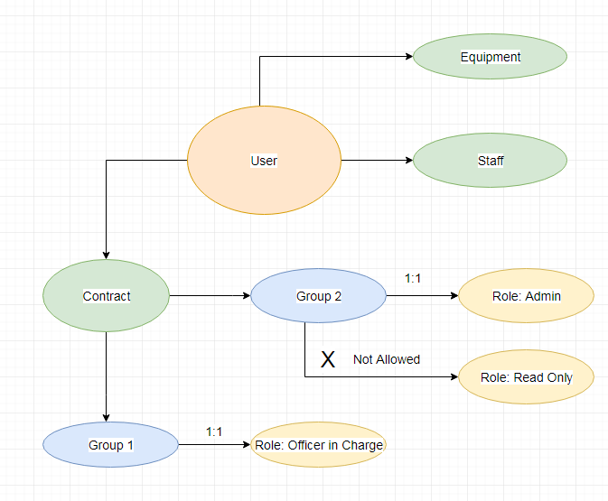

Above diagram, explains the relationship of user with reminder module and groups. Highlights:-

* + User can be present in multiple reminder modules
  + In each module, user can be part of multiple groups
  + In each group though, user will have only one role.

#### View My Group Details

This feature will allow Group Administrator to view Group Details of his or her own user group.

Following details will be shown in view my group details page.

|  |  |
| --- | --- |
| **Fields** | **Remarks** |
| User Group | Dropdown list |
| Group Description | Text |
| Reminder Module | Text |
| Users, Roles, Role Access Rights | A list of users in the group, corresponding user roles and role access rights. |
| Created By | Text |
| Created Date | DD/MM/YYYY HH:MM:SS |
| Last Modified | Text |
| Last Modified Date | DD/MM/YYYY HH:MM:SS |

#### Manage Users and Roles in My Group

This feature will allow Group Administrator to add user, assign or change role of user, or remove user from the group. Following details will be shown or editable in Manage My Group page:

|  |  |  |
| --- | --- | --- |
| **Fields** | **Editable** | **Remarks** |
| User Group | N | Dropdown list  Other fields will be auto populated according to selected User Group |
| Group Description | N | Text |
| Reminder Module | N | Text |
| Users, Roles, Role Access Rights | Y | Group Administrator can search and add user to the list, assign user role, change user role, or remove user from the list. Search of user shall be enhanced by “Search as you type” feature. |
| Created By | N | Text |
| Created Date | N | DD/MM/YYYY HH:MM:SS |
| Last Modified | N | Text |
| Last Modified Date | N | DD/MM/YYYY HH:MM:SS |

## Contract Reminder Module

This module shall allow authorized users for this module to create, search via keyword(s), filter, view, and sort, modify and delete contracts under their own group. Contracts in this case can include procurement contracts, software license subscription and etc. The search via keyword function shall be enhanced by “search as you type” feature. There are 3 main groups of users for this module, namely FMD, Procurement and IT. Each group of users has their own contract records to monitor. For this module, there must be a maker-checker workflow concept to prevent inaccurate data entry and hence leading to inaccurate reminder alerts.

Whenever a contract is submitted for creation / update / deletion / verify / reject, R365 shall prompt up a confirmation dialogue asking user to confirm his action.

Whenever a contract is created / updated / deleted / verified / rejected successfully or unsuccessfully, R365 shall display a confirmation message saying that this contract is created / updated / deleted / verified / rejected successfully or unsuccessfully. Contract Reference Number shall be included in the confirmation message whenever possible.

### Contract Creation

This feature allows authorized user to create contract in his or her user group. Following details will be entered to create new contract.

|  |  |  |
| --- | --- | --- |
| **Fields to be entered** | **Remarks** | **Fields to be displayed** |
| Contract Details | | Contract title |
| User Group | Dropdown List  Group description will be auto populated according to selected User Group and displayed next to User Group field |  |
| Contract Title* | Text area | Start date |
| Contract Reference Number* | Text | Expiry date |
| BA / PO number* | Number (0 decimal place) | Supplier |
| Supplier* | Text |  |
| Contract Value Currency* | Text (3 letters) | Officer in charge |
| Contract Value* | Number (2 decimal place) |  |
| Performance Bond submission* | Format: Y / N / N.A |  |
| Start Date* | Format: DD/MM/YYYY |  |
| Expiry Date* | Format: DD/MM/YYYY |  |
| Reminder Status | Active(default)/Inactive |  |
| First Reminder Date* | Format: DD/MM/YYYY  Auto populated according to default set up in administrative module and editable |  |
| Second Reminder Date | Format: DD/MM/YYYY  Auto populated according to default set up in administrative module and editable |  |
| Third Reminder Date | Format: DD/MM/YYYY  Auto populated according to default set up in administrative module and editable |  |
| Officer in Charge* | Dropdown list.  Select officer in charge from the users within the group |  |
| Cc list | Text.  Email(s) separated by semicolon |  |
| Reviewer List* | Dropdown list.  Select update to two reviewers from the users within the group |  |
| Option year | |  |
| Option year exercise date | Format: DD/MM/YYYY  Default value: NIL |  |
| Insurance |  |  |
| Public Liability policy expiry date | Format: DD/MM/YYYY  Default value: NIL |  |
| Workman Compensation policy expiry date | Format: DD/MM/YYYY  Default value: NIL |  |
| Hull & Marine expiry date | Format: DD/MM/YYYY  Default value: NIL |  |
| Savings | |  |
| Savings currency | Text (3 letters) |  |
| Savings | Number (2 decimal place) |  |

*Mandatory field

Other fields might be identified and need to be captured for contract details in future without affecting the existing workflow.

User submits the form with mandatory details for creation of contract, which then goes through verification process (Maker-checker workflow) before the contract is activated for view.

### Update Contracts

This feature allows authorized user to update contract details in his or her user group. Following details will be displayed or editable in update contract page.

|  |  |  |
| --- | --- | --- |
| **Fields** | **Editable** | **Remarks** |
| Contract Details |  |  |
| User Group | N | Group description will be auto populated according to selected User Group and displayed next to User Group field |
| Contract Title* | Y | Text area |
| Contract Reference Number* | Y | Text |
| BA / PO number* | Y | Number (0 decimal place) |
| Supplier* | Y | Text |
| Contract Value Currency* | Y | Text (3 letters) |
| Contract Value* | Y | Number (2 decimal place) |
| Performance Bond submission* | Y | Format: Y / N / N.A |
| Start Date* | Y | Format: DD/MM/YYYY |
| Expiry Date* | Y | Format: DD/MM/YYYY |
| Reminder Status | Y | Active(default)/Inactive |
| First Reminder Date* | Y | Format: DD/MM/YYYY  Auto populated according to default set up in administrative module and editable |
| Second Reminder Date | Y | Format: DD/MM/YYYY  Auto populated according to default set up in administrative module and editable |
| Third Reminder Date | Y | Format: DD/MM/YYYY  Auto populated according to default set up in administrative module and editable |
| Officer in Charge* | Y | Dropdown list.  Select officer in charge from the users within the group |
| Cc list | Y | Text.  Email(s) separated by semicolon |
| Reviewer List* | Y | Dropdown list.  Select update to two reviewers from the users within the group |
| Option year |  |  |
| Option year exercise date | Y | Format: DD/MM/YYYY  Default value: NIL |
| Insurance |  |  |
| Public Liability policy expiry date | Y | Format: DD/MM/YYYY  Default value: NIL |
| Workman Compensation policy expiry date | Y | Format: DD/MM/YYYY  Default value: NIL |
| Hull & Marine expiry date | Y | Format: DD/MM/YYYY  Default value: NIL |
| Savings |  |  |
| Savings currency | Y | Text (3 letters) |
| Savings | Y | Number (2 decimal place) |
| Created By | N | Text |
| Created Date | N | DD/MM/YYYY HH:MM:SS |
| Last Modified | N | Text |
| Last Modified Date | N | DD/MM/YYYY HH:MM:SS |

After user submits update of the contract details, updated details will go through verification process (Maker-checker workflow) before the updated details are activated for view.

However, if only “Reviewer List” is updated, contract details will be directly updated without going through verification process.

### Delete Contracts

This feature allows authorized user to delete contract in his or her user group.

After user submits to delete the contract, deletion details will go through verification process (Maker-checker workflow) before the contract is actually deleted.

### Renewing Contracts

This feature is provided for the users to use an existing contract and create a new contract in the system. User can select any existing contract and click renew button to renew the contract. After clicking renew button, user will be redirected to add reminder page, with following fields copied from the original reminder.

|  |
| --- |
| **Fields to copied from original contracts** |
| Contract Details |
| User Group |
| Contract Title |
| BA / PO number |
| Supplier |
| Contract Value Currency |
| Contract Value |
| Performance Bond submission |
| Reminder Status |
| Officer in Charge |
| Cc list |
| Reviewer List |
| Option year |
| Option year exercise date |
| Insurance |
| Public Liability policy expiry date |
| Workman Compensation policy expiry date |
| Hull & Marine expiry date |
| Savings |
| Savings currency |
| Savings |

After user submits the renewal, system will prompt user to delete, inactivate, or do nothing to the original contract. Relevant verification process (Maker-checker flow) for create, update or delete contract shall apply.

### Maker-checker workflow

Workflow Diagram:-

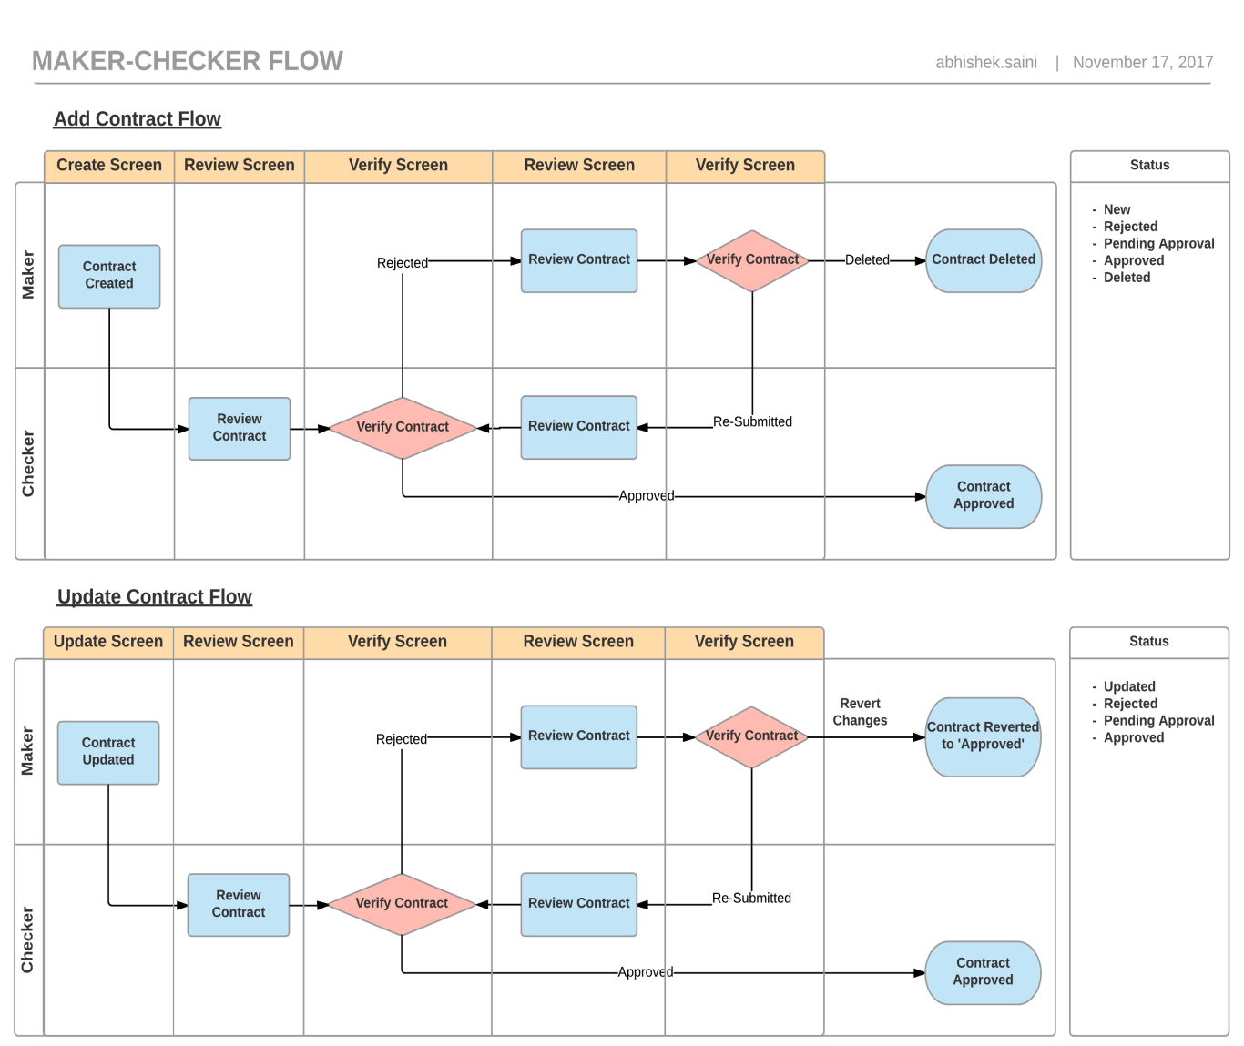

Edit contract details

Edit contract details

Above diagram shows the maker-checker workflow in the R365 while creating and updating the contract.

After filling in the mandatory details, user will submit the contract for verification and the status of the contract will be ‘Verify’. All the newly created contracts will be viewable in the verification sections for review, only contract “Reviewer” can view and verify “Pending Approval” contracts.

#### Add Contract

* + Maker creates a new contract, the contract status will be set to “New”, and an email will be sent to checker (Reviewer) and cc maker to notify that a new contract has been created and pending for verification.
  + Maker can make as many changes as possible till the checker comes and update the status to either Reject or Verified. Whenever a new change is submitted, a new notification email will be sent to checker and cc maker to notify the changes.
  + If checker verifies the new contract, contract status will be updated to “Verified”. An email will be sent to maker and cc checker to notify that new contract has been verified.
  + If checker rejects the new contract, contract status will be updated to 'Rejected'. An email will be sent to maker and cc checker to notify that new contract has been rejected.
  + If a contract is rejected, maker can either correct the details and re-submit it for verification, or delete the contract.

#### Update Contract

* + Every time there is a change or update in the contract, it follows the maker checker workflow. If contract is already created and basically, verified by the checker it shows up in the view contract screen
  + If any user, goes and update the contract then the user is the maker in this case and maker makes the update, it will go into 'Updated' status. Now, the user verifying this contract becomes the checker.
  + Now, checker can either verify or reject the contract. If Checker rejects the contract then it will change to 'Rejected' status.
  + Maker now, will have the option either to update the changes and re-submit or there would be a button 'Revert changes'. On click of 'Revert Changes', it would go back to the same state before it was initially submitted to checker.

#### Delete Contract

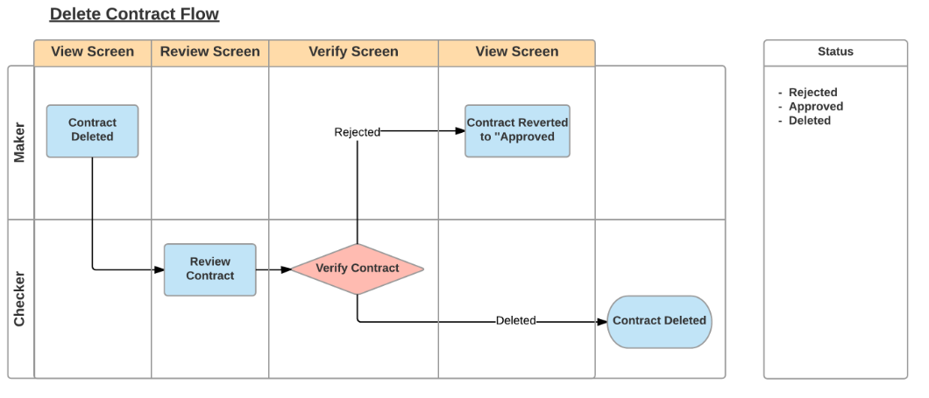

* + When user tries to delete the contract then it goes maker-checker flow too. Delete contract goes to review screen with status as ‘Deleted’, checker comes and verify the state
  + If checker finds the contract can be deleted then checker deletes the contract and it is not visible in the system. And in case, checker feels the contract is fine and shouldn’t be deleted then the user clicks on reject and the contract goes back to the previous status of ‘Approved’ and will show up in view screen

### Reminder Calendar

In contract reminder home page, there will be a reminder calendar. Expiry date(s) of all the active contract(s) in the login user’s group(s) will be highlighted on the reminder calendar.

### Contract Reminder Summaries

In contract reminder home page, following summary statistics of contract reminders under user’s group will be shown. If user clicks the summary box, corresponding contract list will be shown in the search results.

* + No. of Contracts Expired
  + No. of Contracts Expiring this Month
  + No. of Contracts Expiring next Month
  + No. of Contracts Need Verification

### Search Contracts

This feature shall allow user to search contracts of his or her user group(s) via any field displayed in the contract list. The search via keywords function will be enhanced by search as you type feature. “Contract Reference Number”, “Contract Title”, “Start Date”, “Expiry Date”, “Reminder”, “Supplier”, “Officer-in-Charge” will be the default fields shown in the contract list. However, there will be an option for user to choose additional fields to be displayed, or hide existing fields in the contract list.

If a grid or table cell is too small to display the full content, only partial information will be shown. However full content will be displayed in a tooltip whenever user mouse over on that field.

By default, 20 contracts will be shown in one search result page. However, there will be an option for user to configure the number of contracts to be shown in one result page.

### Sort Contacts

This feature will allow user to sort contracts in search result by any column in the result list. By default, contracts will be sorted by expiry date in descending order.

### Download Contracts

This feature will allow user to download contract search results in to an excel sheet. All relevant and meaningful information of the contract details will be downloaded.

### Reminder Workflow

This feature describes how the reminders are set, based on which the reminder is trigged to the user for specific contracts. There will be up to 3 reminders set for every contract as First Reminder Date, Second Reminder Date and Third Reminder Date on which the reminder should be triggered.

On the respective first, second and third reminder date, notification email will be sent with following recipients:

* + TO List:
    - Officer in Charge of this contract
    - Users in the Group who have “Notification TO” access right
  + CC List
    - Emails configured in contract CC List
    - Users in the group who have “Notification CC” access right

User will be able to view the reminders status from the view contract screen as a quick snapshot. There will be 3 icons to indicate the stage of the reminder. If only one icon is highlighted then it indicates first reminder is sent, for 2 icons it indicates second reminder is sent and for 3rd icon it indicates all 3 reminders are sent.

Note: - Reminder Format will be DD/MM/YYYY

### Email for Expiring Contracts

On the respective first, second and third reminder date, notification email will be sent with following recipients:

* + TO List:
    - Officer in Charge of this contract
    - Users in the Group who have “Notification TO” access right
  + CC List
    - Emails configured in contract CC List
    - Users in the group who have “Notification CC” access right

Run the email engine every day and trigger email when the following conditions are matched:-

* + Contract is Active, Expiry Reminder is not sent and Expiry Date <= Current Date, or
  + Contract is Active, 3rd Reminder is not sent and 3rd Reminder Date <= Current Date, or
  + Contract is Active, 2rd Reminder is not sent and 2rd Reminder Date <= Current Date, or
  + Contract is Active, 1rd Reminder is not sent and 1rd Reminder Date <= Current Date, or

### Transaction Logs

Every transactional action shall be logged in the application log and database. Following actions on the screen in our system requires logging (To be reviewed):-

* + All transactions changing database records (eg. Contract reminder, user, group, role details, notification records, etc.) Shall be logged in application log and database.
  + If someone manually updates records from R365 database, such action must also be logged in database audit table.

## Equipment Reminder Module

This module shall allow authorized users for this module to create, search via keyword(s), filter, view, and sort, modify and delete equipment reminder records under their own group. The search via keyword function shall be enhanced by “search as you type” feature. There are 2 main groups of users for this module, namely FMD-Operation and FMD-Technical service. Each group of users has their own equipment to monitor and they cannot manage equipment of the other groups unless being granted the necessary roles necessary roles of that group. Whenever an equipment reminder is submitted for creation / update / deletion / verify / reject, R365 shall prompt up a confirmation dialogue asking user to confirm his action.

Whenever an equipment reminder is created / updated / deleted / verified / rejected successfully or unsuccessfully, R365 shall display a confirmation message saying that this contract is created / updated / deleted / verified / rejected successfully or unsuccessfully. Equipment reminder Reference Number shall be included in the confirmation message whenever possible.

### Equipment Reminder Creation

This feature allows authorized user to create Equipment Reminder in his or her user group. Following details will be entered to create new equipment reminder:-

|  |  |  |
| --- | --- | --- |
| **Fields to be entered** | **Mandatory** | **Remarks** |
| Reminder ID | YES | - Auto generated |
| User Group | YES | - Retrieve from login user's group.  - Select from dropdown list if user has more than 1 equipment groups - Display group description next to User Group field. Group description will be keyed in when overall admin creates group. |
| Equipment Type | YES | - Dropdown list  - Available equipment types are managed by administrative module.  - See "equipment type & sub type" worksheet for sample values |
| Equipment Sub Type | YES | - Dropdown list - Available equipment sub types are managed by administrative module - Equipment sub types will be filtered according to the selected equipment type |
| Equipment ID | NO | Text |
| Description | NO | Textbox, keyed in by user. |
| Location | YES | - Search as you type - Available locations are managed by administrative module |
| Uploaded Files | NO | - Allow user to upload, download and remove files (excel, pdf, word etc) |
| Start Date | NO | DD/MM/YYYY |
| Expiry Date | YES | DD/MM/YYYY |
| First Reminder Date | YES | - Auto populated according to the default configuration of the selected equipment sub type in administrative module - Editable  -  DD/MM/YYYY |
| Second Reminder Date | NO |
| Third Reminder Date | NO |
| Remarks | NO | Text |
| Created By |  | - display in view, edit, delete page |
| Created Time |  | - display in view, edit, delete page |
| Last Modified By |  | - display in view, edit, delete page |
| Status | Yes | - Radio button - Active / Inactive - In view / delete page, If reminder is expiring, also display status "Expiring" - In view / delete page, If reminder is expired, also display status "Expired" |

Other fields might be identified and need to be captured for equipment reminder details in future without affecting the existing workflow.

User submits the form with mandatory details for creation of equipment reminder.

# Performance

Refer to Technical Requirement Design Specification (TRDS) Document

# Interface Requirements

# Operational Requirements

## Logging requirement (application logs)

All updates shall be logged for audit trail purpose. The audit log shall consist of the following information:

* Transaction ID
* User Id
* Date Time
* Change Logs

Activity type (Add, update and delete)

10.2. Housekeeping requirement

All records shall be available in production database for six month. Thereafter it will be housekeep.

All records shall be archived in a daily basis. The user shall be able to view the archived records via reporting utility. The archived records will be permanently deleted after 2 years.

# Security/Control Requirements

Refer to Security/Control Documents.

# Documentation Requirements

a) User's manuals

To updated with new screens and procedures

b) User acceptance document

To be provided by users

c) Error reporting procedure

Via JIRA

# User Training Requirements

Training session will be provided before system rollout. Detailed schedule will be provided after UAT.

# Output Requirements

Non Applicable

# Paging Requirements

Non Applicable

# User acceptance criteria

System shall be accepted if it satisfies the functional specifications stated in this document and upon the successful User Acceptance testing and sign off by the user.